Animation of symmetric operations

The animation in the program requires improvement; therefore, it is highly recommended to utilize Symmetry@Otterbein and PGLite for animated demonstrations of symmetry operations. If one wishes to employ the current program for showcasing symmetry operations through animation, the following steps can be followed.

1. Open VMD, drag the molecules in the Resources folder into the VMD window and input the following command in the Console:

set allatom [atomselect top all]

set m0 [transoffset [vecinvert [measure center $allatom weight mass]]]

$allatom move $m0

These operations aim to move the center of the molecule to the coordinate origin.

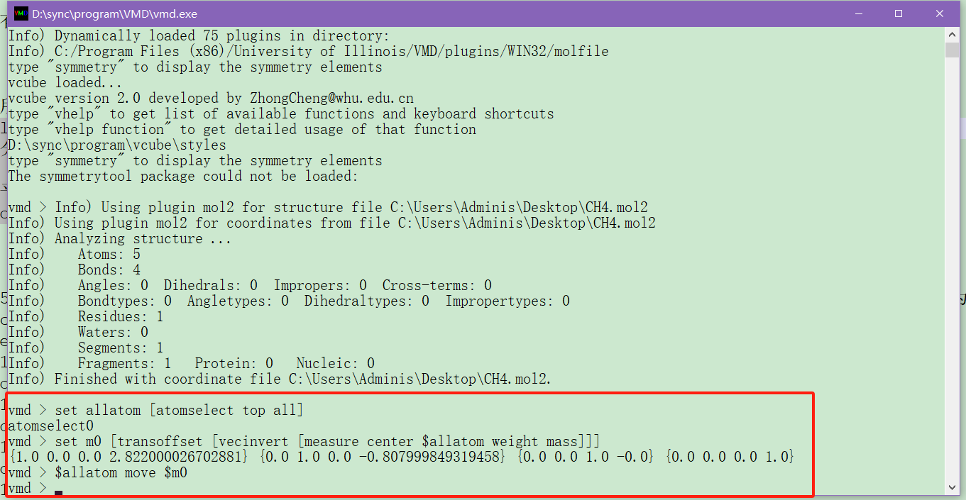

1. From the menu of VMD, select Extensions -> Analysis -> Symmetry Tool. Then, in the Symmetry Tool window that appears, click on the Guess-Symmetry button to display symmetry elements and point groups.

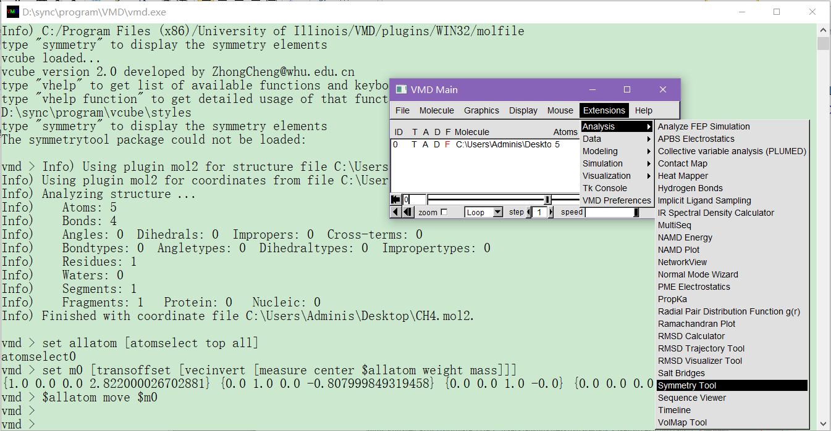

1. Redrag the molecules from the Resources folder into the VMD window, and input the following command in the Console:

set allatom [atomselect top all]

set m0 [transoffset [vecinvert [measure center $allatom weight mass]]]

$allatom move $m0

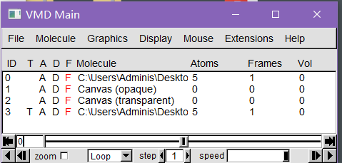

1. Animation demonstration of rotation. Copy the code below to the command line of VMD. Please revise the highlighted text. The red-highlighted section indicates the axis of rotation. The blue-highlighted part represents one-tenth of the rotation angle. Due to limitations in VMD's TCL scripting, a suitable method for animating in a loop has not been identified. As a workaround, the operations need to be repeated 10 times.

set vec {0.5773 -0.4083 0.7071}

set rdeg 18

after 100

$allatom move [ trans axis $vec $rdeg deg ]

after 100

$allatom move [ trans axis $vec $rdeg deg ]

after 100

$allatom move [ trans axis $vec $rdeg deg ]

after 100

$allatom move [ trans axis $vec $rdeg deg ]

after 100

$allatom move [ trans axis $vec $rdeg deg ]

after 100

$allatom move [ trans axis $vec $rdeg deg ]

after 100

$allatom move [ trans axis $vec $rdeg deg ]

after 100

$allatom move [ trans axis $vec $rdeg deg ]

after 100

$allatom move [ trans axis $vec $rdeg deg ]

after 100

$allatom move [ trans axis $vec $rdeg deg ]

1. Animation demonstration of reflection. Copy the code below into the command line of VMD. Please revise the highlighted text. The red-highlighted section indicating the symmetric plane. The green-highlighted part represents the number of atoms in the molecule.

set vec {0.0000 0.8660 0.5000}

set natom 5

for {set i 1} {$i <= $natom} {incr i} {

array set atom_ ""

array set vscale_ ""

array set vatom_ ""

set atom_($i) [atomselect top "serial $i"]

set vatom_($i) [lindex [$atom_($i) get {x y z}] 0]

set vscale_($i) [vecdot $vec $vatom_($i)]

set vscale_($i) [expr {0.2*$vscale_($i)}]

$atom_($i) moveby [vecscale $vscale_($i) [vecinvert $vec]]

}

after 100

for {set i 1} {$i <= $natom} {incr i} {

$atom_($i) moveby [vecscale $vscale_($i) [vecinvert $vec]]

}

after 100

for {set i 1} {$i <= $natom} {incr i} {

$atom_($i) moveby [vecscale $vscale_($i) [vecinvert $vec]]

}

after 100

for {set i 1} {$i <= $natom} {incr i} {

$atom_($i) moveby [vecscale $vscale_($i) [vecinvert $vec]]

}

after 100

for {set i 1} {$i <= $natom} {incr i} {

$atom_($i) moveby [vecscale $vscale_($i) [vecinvert $vec]]

}

after 100

for {set i 1} {$i <= $natom} {incr i} {

$atom_($i) moveby [vecscale $vscale_($i) [vecinvert $vec]]

}

after 100

for {set i 1} {$i <= $natom} {incr i} {

$atom_($i) moveby [vecscale $vscale_($i) [vecinvert $vec]]

}

after 100

for {set i 1} {$i <= $natom} {incr i} {

$atom_($i) moveby [vecscale $vscale_($i) [vecinvert $vec]]

}

after 100

for {set i 1} {$i <= $natom} {incr i} {

$atom_($i) moveby [vecscale $vscale_($i) [vecinvert $vec]]

}

after 100

for {set i 1} {$i <= $natom} {incr i} {

$atom_($i) moveby [vecscale $vscale_($i) [vecinvert $vec]]

}

1. Animation demonstration of improper rotation. Copy the code below into the command line of VMD. Please revise the highlighted text. The red-highlighted section indicating the improper rotation. The green-highlighted part represents the number of atoms in the molecule. The blue-highlighted part represents one-tenth of the rotation angle.

set vec {0.5773 -0.4083 0.7071}

set rdeg 9

set natom 5

after 100

$allatom move [ trans axis $vec $rdeg deg ]

after 100

$allatom move [ trans axis $vec $rdeg deg ]

after 100

$allatom move [ trans axis $vec $rdeg deg ]

after 100

$allatom move [ trans axis $vec $rdeg deg ]

after 100

$allatom move [ trans axis $vec $rdeg deg ]

after 100

$allatom move [ trans axis $vec $rdeg deg ]

after 100

$allatom move [ trans axis $vec $rdeg deg ]

after 100

$allatom move [ trans axis $vec $rdeg deg ]

after 100

$allatom move [ trans axis $vec $rdeg deg ]

after 100

$allatom move [ trans axis $vec $rdeg deg ]

for {set i 1} {$i <= $natom} {incr i} {

array set atom_ ""

array set vscale_ ""

array set vatom_ ""

set atom_($i) [atomselect top "serial $i"]

set vatom_($i) [lindex [$atom_($i) get {x y z}] 0]

set vscale_($i) [vecdot $vec $vatom_($i)]

set vscale_($i) [expr {0.2*$vscale_($i)}]

$atom_($i) moveby [vecscale $vscale_($i) [vecinvert $vec]]

}

after 100

for {set i 1} {$i <= $natom} {incr i} {

$atom_($i) moveby [vecscale $vscale_($i) [vecinvert $vec]]

}

after 100

for {set i 1} {$i <= $natom} {incr i} {

$atom_($i) moveby [vecscale $vscale_($i) [vecinvert $vec]]

}

after 100

for {set i 1} {$i <= $natom} {incr i} {

$atom_($i) moveby [vecscale $vscale_($i) [vecinvert $vec]]

}

after 100

for {set i 1} {$i <= $natom} {incr i} {

$atom_($i) moveby [vecscale $vscale_($i) [vecinvert $vec]]

}

after 100

for {set i 1} {$i <= $natom} {incr i} {

$atom_($i) moveby [vecscale $vscale_($i) [vecinvert $vec]]

}

after 100

for {set i 1} {$i <= $natom} {incr i} {

$atom_($i) moveby [vecscale $vscale_($i) [vecinvert $vec]]

}

after 100

for {set i 1} {$i <= $natom} {incr i} {

$atom_($i) moveby [vecscale $vscale_($i) [vecinvert $vec]]

}

after 100

for {set i 1} {$i <= $natom} {incr i} {

$atom_($i) moveby [vecscale $vscale_($i) [vecinvert $vec]]

}

after 100

for {set i 1} {$i <= $natom} {incr i} {

$atom_($i) moveby [vecscale $vscale_($i) [vecinvert $vec]]

}